MEDIA RELEASE
For immediate release November 2019
Tax goldmines for renovators
Australia’s largest provider of tax depreciation schedules has revealed a list of common renovation items that hold lucrative tax deductions for property investors.
BMT Tax Depreciation has worked with more than half a million Australian property investors to help them uncover legitimate tax deductions for the wear, tear, and ageing of their investment properties.
The CEO of BMT, Bradley Beer said that property investors would be wise to develop their understanding of the tax benefits of certain assets as doing so could lead to a more successful renovation project from multiple angles.
“Many property owners renovate to add value to their property but often fail to take into account the tax ramifications of different renovation strategies,” said Bradley Beer.
“By considering the depreciable value of renovation items before starting work, investors can enjoy the double benefit of improving their cash flow and increasing the value of their property."
From a list of common renovation items, Mr Beer singled out carpet, split system air conditioners, curtains and removable light shades as assets that can have lucrative tax benefits for owners of income producing properties.
“New carpet that costs $4,000 can not only make a property more attractive for tenants but holds a remarkable $1,000 in tax deductions in the first year alone. To put this into perspective, a property investor who installs tiles of the same value can only claim a first year deduction of $100,” said Bradley Beer.
“By simply considering the depreciable value of these flooring assets, a savvy investor can boost their cash flow by $900 after renovations in the first year.”
Mr Beer also noted that complementing the new carpet with $2,000 worth of curtains can entitle the property investor to claim an additional $667 in the first year. By comparison, shutters of the same value allow a deduction of just $50.
Property investors can apply the same principle to multiple items that are commonly purchased and installed during renovations including air conditioning systems and lighting.
“Many investors have debated the merits of installing split systems. Some people in this group may not be aware that purchasing and installing two split system units for $6,000 attracts a first year depreciation deduction of $1,200, whereas a ducted air conditioning system only offers $800,” said Bradley Beer.
“Removable light shades collectively worth $1,100 allow investors to claim a whopping $440 in the first full year of ownership. That’s nearly half the cost of the assets in the first financial year.”
Mr Beer noted that significant depreciation deductions are available to investors irrespective of the size or scale of the renovation project.
“Regardless of the size of your renovation budget, most investors will be able to claim depreciation deductions in one form or another,” said Bradley Beer.
“Property investors looking to maximise their cash flow during and after renovations should speak to a qualified Quantity Surveyor before starting work. This approach could lead to a more successful renovation while helping to ensure that no items remain unclaimed at the end of the process,” said Bradley Beer.
- ENDS –
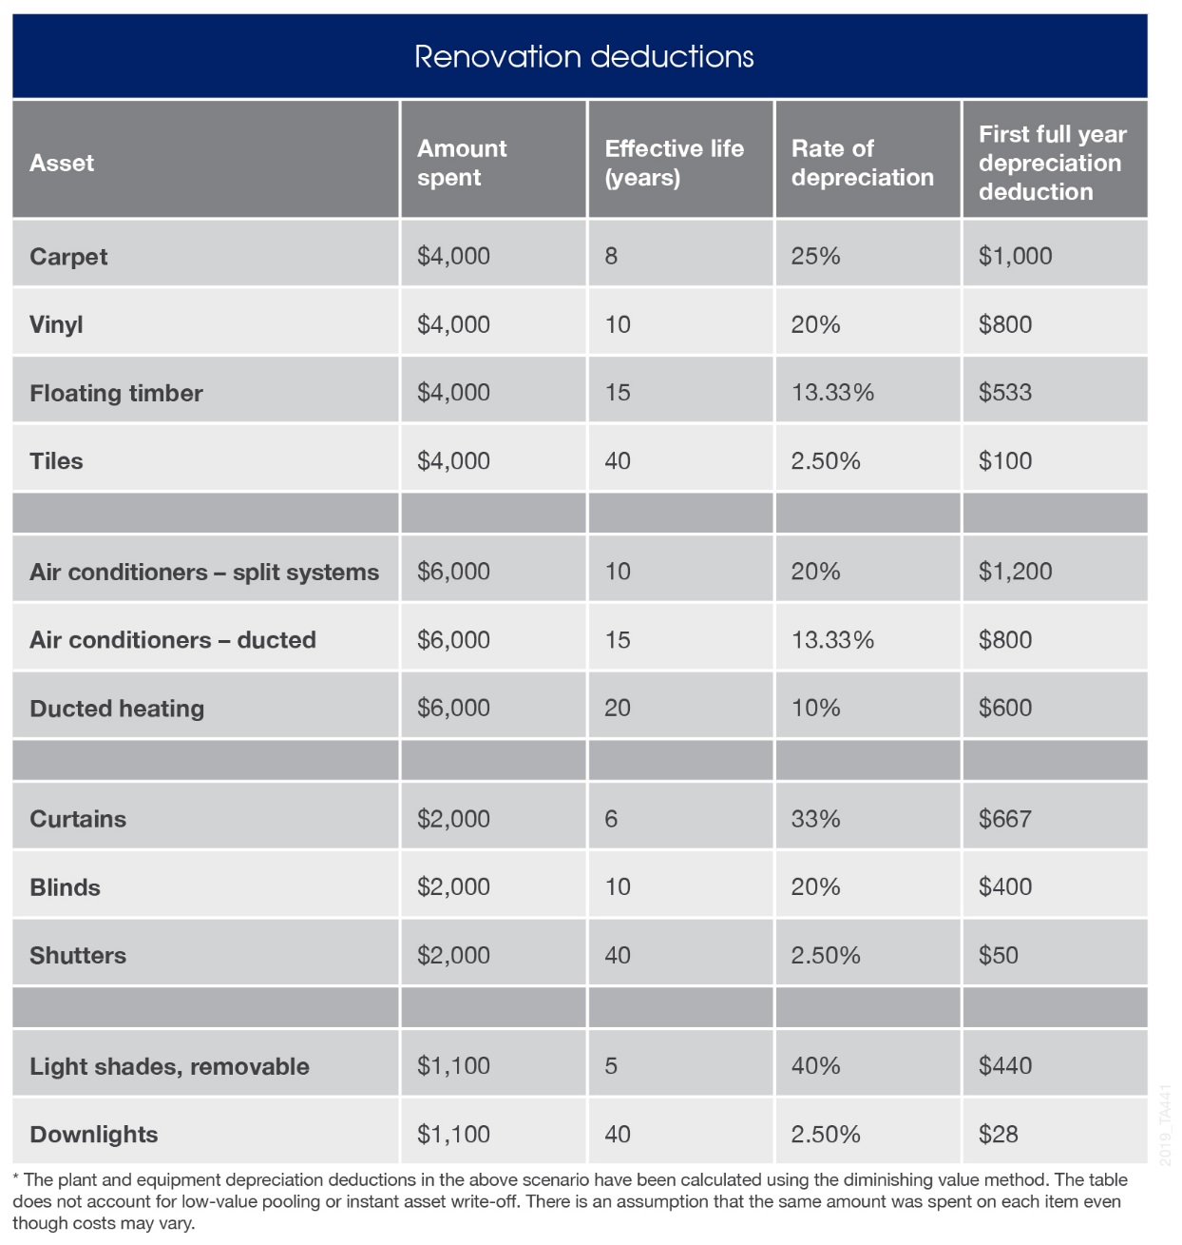

For all media enquires please contact:
Bradley Beer
CEO, BMT Tax Depreciation
Phone: 0413 271 777
Email: media@bmtqs.com.au

About BMT Tax Depreciation
BMT Tax Depreciation (BMT) is a Quantity Surveying company specialising in the provision of tax depreciation schedules for residential and commercial investment properties. Commencing business in 1997, demand from property investors nationally has seen business expand Australia-wide with offices now located in Sydney, Parramatta, Melbourne, Brisbane, Newcastle, Adelaide, Perth, Gold Coast, Cairns, Canberra, Hobart and Darwin.

